RESEARCH ARTICLE
Title Should be in Times New Roman 18
¹Name, ²Name, ³Name
¹(Department Name, College Name…, India
Email: id@gmail.com)
------------------------------------**************----------------------------------
Abstract:
Abstract content 150 to 200 words with 1.5 line spacing.

Keywords — Keyword 1, Keyword 2, Keyword 3.
----------------------------------------************************----------------------------------
- INTRODUCTION
The improvements of the mechanical performance of extrusion - compression moulded Natural Fibre Composite(NFC) should be possible to achieve using micromechanical analysis and tailoring the microstructure accordingly by optimizing the manufacturing processes.[1-4]
2. Materials & Methods
2.1 Chemical Treatment for Interfacial Adhesion
Natural fiber composites are also claimed to offer environmental advantages such as reduced dependence on non-renewable energy/material sources, lower pollutant emissions, lower greenhouse gas emissions, enhanced energy recovery, and end of life biodegradability of components. For this research, kenaf fiber is used instead of other natural fiber.

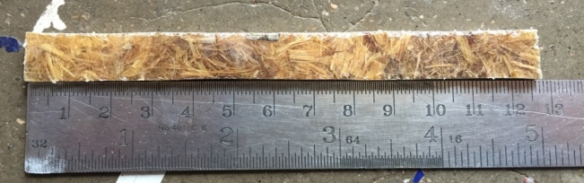
Figure 1 Flexural Bending Test Specimen
Total length in (mm) | Span length in  (mm) | Width in  (mm) | Thickness in  (mm)
125 | 100 | 12.5 | 3
Table 1 Dimension for Flexural Bending Test
3. Result & Discussion
The study demonstrates the potential of single-stage processing for the production of natural fiber-reinforced thermoplastic composites, successfully integrating extrusion with compression molding..
Acknowledgement
Authors would like to thank the financial support for this project XXXX…
REFERENCES
[1] Faruk, O., Bledzki, A. K., Fink, H. P., & Sain, M. (2012). Biocomposites reinforced with natural fibers: 2000–2010. Progress in Polymer Science, 37(11), 1552–1596.
[2] Puglia, D., Biagiotti, J., & Kenny, J. M. (2005).
A review on natural fibre-based composites—Part II: Application of natural reinforcements in composite materials for automotive industry. Journal of Natural Fibers, 1(3), 23–65.
[3] Shah, D. U. (2013). Characterising the anisotropic tensile properties of hemp fibres for natural fibre composite applications. Composite Science and Technology, 81, 41–48.
[4] Saba, N., Paridah, M. T., & Jawaid, M. (2015). A review on dynamic mechanical properties of natural fibre reinforced polymer composites. Construction and Building Materials, 106, 149–159.
[5] Piggott, M. R. (1980). Load Bearing Fibre Composites. Pergamon Press.(Foundational text for fibre–matrix interaction concepts.) ISBN 978-1483182155

